Project Title: **“Laundry Management System”**

(By SEMESTER – V of III Year M.Sc. (CA & IT) 2020-21)

Submitted By:

1. Prince Talaviya – 3073
2. Shubhank Shah – 3160
3. Deep Asmani – 3170

Group-41

Name of Company: **New Fashion Dry Cleaners**

Date of submission: 05/01/2021

Submitted To

K. S. School of Business Management

M.Sc. - Computer Ap plications and Information Technology.

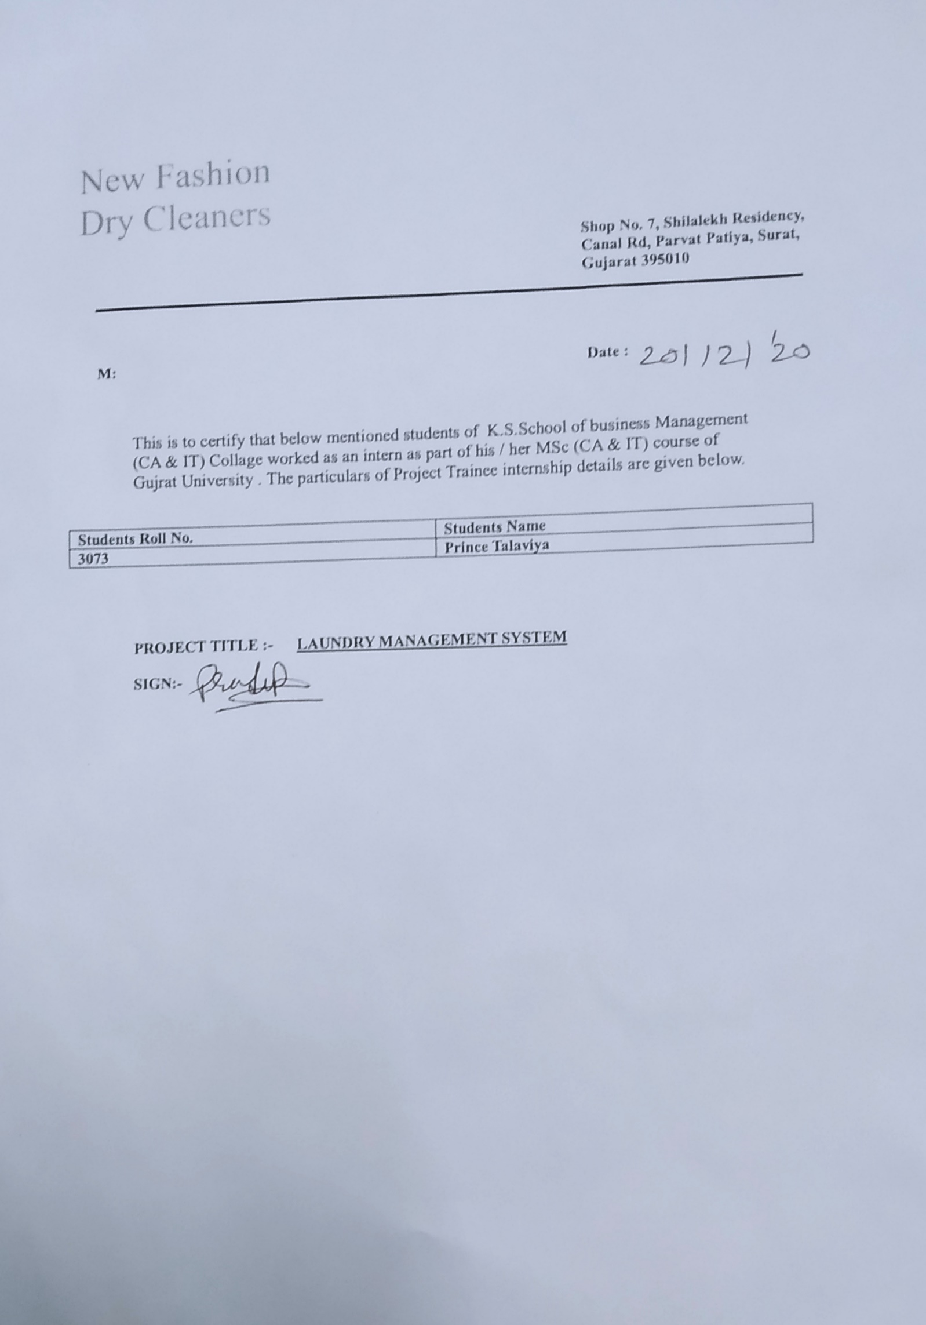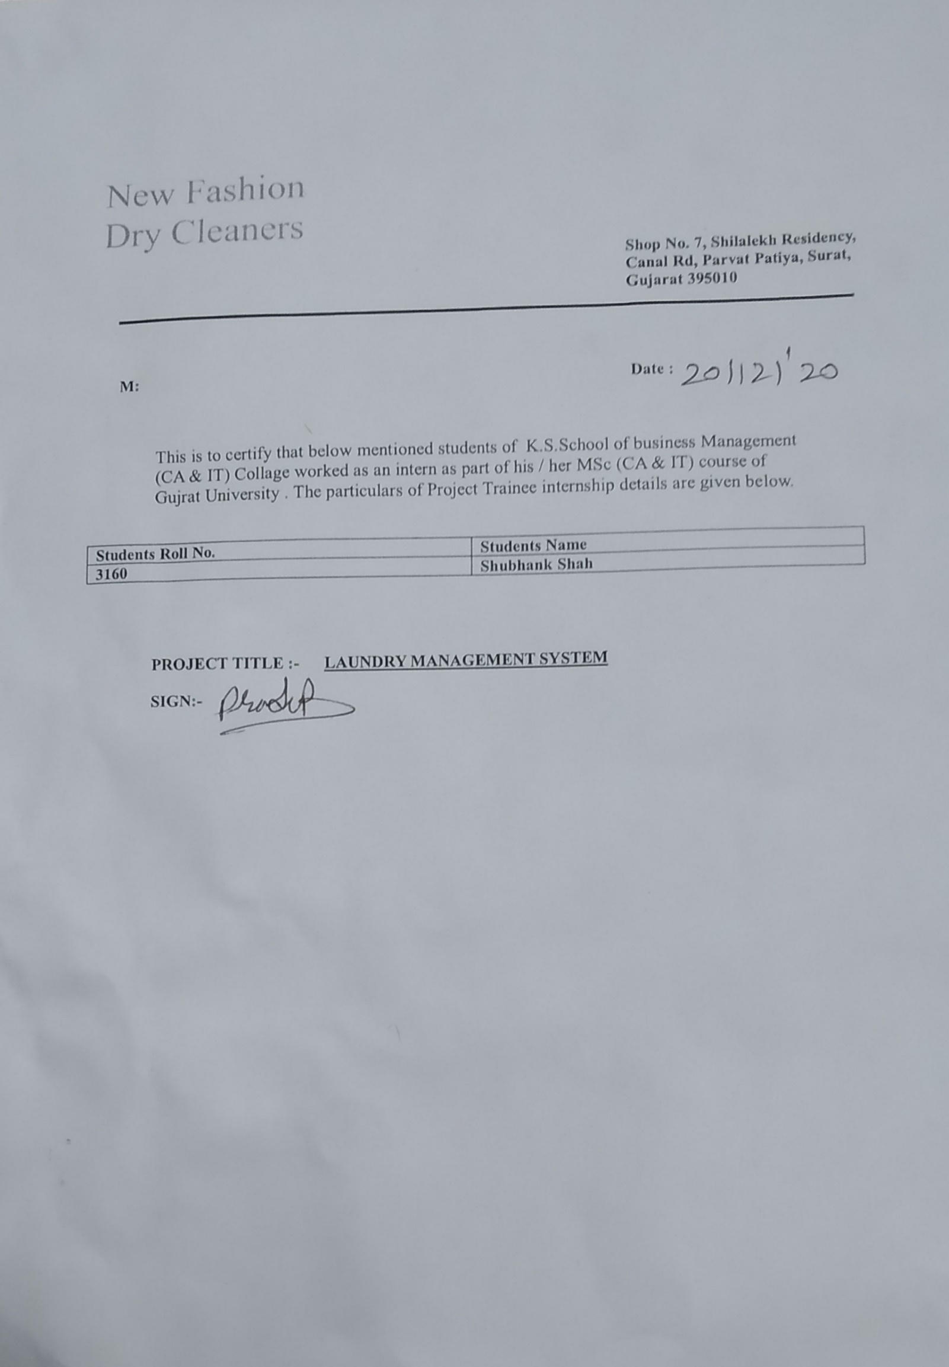

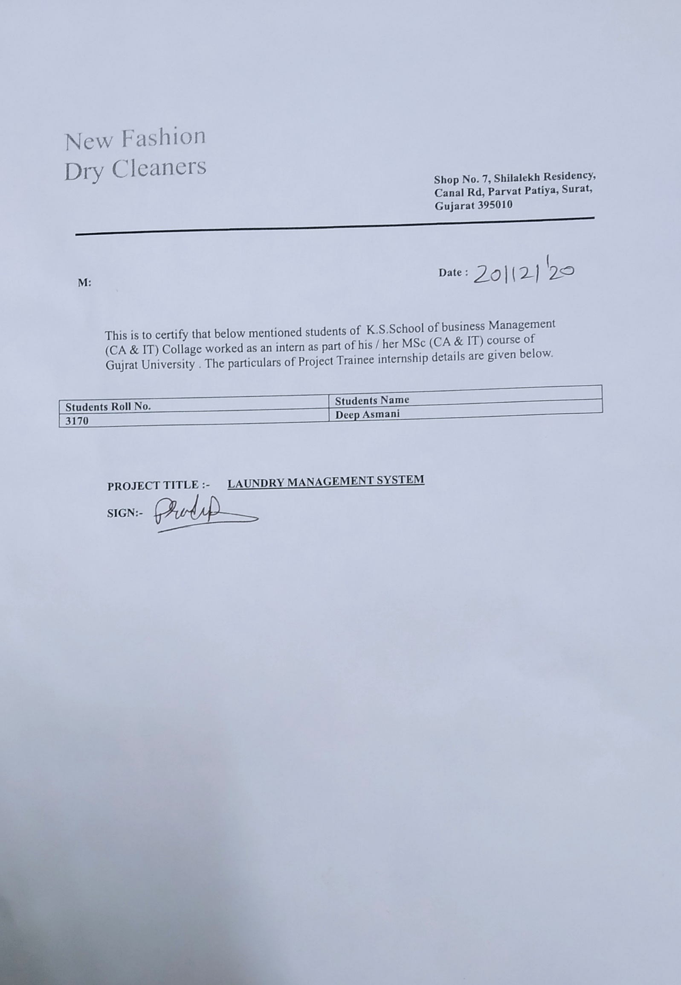

**Acknowledgement**

This is a very auspicious moment when our project is successfully implemented. Our 5th semester is almost finished and we are about to enter into the new waters of working in a corporate environment after completing this semester. All these things would not have happened if we had not got the constant support and encouragement from certain people. At this happy moment We would like to thank the people who have been part of the whole process of our project creation and who, despite our mistakes and blunders, kept trust in our abilities and provided us the opportunity to reach this far in my educational journey.

First of all, thank our “K.S. SCHOOL OF BUSINESS MANAGEMENT” for letting us be a part of it and the staff for their constant help. A big thank you to Mr. Jayraj Pandya, the director of the department, for providing us this opportunity to learn in depth.

We are very much thankful to my project guide whose constant guidance and support made the project possible. At every stage he encouraged us out of our problems and pointed out our mistakes in early stages so that our final project would turn out to be perfect.

And last but not least We would like to thank our family and friends. At times when the workload would tire us and we felt very down it was them who helped us to remember and realize our dream of creating this project. At every troubled moment they were always there for us. We feel very lucky to have been blessed with such a loving family and caring friends

Table of Contents

**1**  **INTRODUCTION** 1

**1.1** **ORGANIZATION PROFILE** 2

**1.2** **SYSTEM DETAILS** 2

**1.2.1 EXISTING SYSTEM** 2

**1.2.2 PROPOSED SYSTEM** 2

**1.3** **SCOPE OF SYSTEM** 3

**1.4** **OBJECTIVES** 3

**2** **PROPOSED SYSTEM REQUIREMENT GATHETING** 5

**2.1** **STAKEHOLDER OF SYSTEM** 5

**2.2** **REQUIREMENT GATHERING TECHNIQUE USED** 5

**2.3** **CONSOLIDATED LIST OF REQUIREMENTS** 9

**2.4** **PROJECT DEFINITION** 9

**3** **SYSTEM ANALYSIS AND DESIGN** 11

**3.1** **FEASIBILITY STUDY** 11

**3.1.1** **TECHNICAL STUDY** 11

**3.1.2** **ECONOMICAL STUDY** 11

**3.1.3** **OPERATIONAL STUDY** 11

**3.2** **HARDWARE – SOFTWARE REQUIREMET** 12

**3.2.1** **HARDWARE REQUIREMET** 12

**3.2.2** **SOFTWARE REQUIREMET** 12

**3.3** **SYSTEM PLANNING** 13

**3.3.1** **WORK BREAKDOWN STRUCTURE** 13

**3.3.2** **GANTT CHART** 14

**3.4** **PROCESS MODEL** 14

**4** **SYSTEM ANALYSIS AND PLANNING** 16

**4.1** **UML (UNIFIED MODELING LANGUAGE)** 16

**4.1.1** **Use Case Diagram** 16

**4.1.2** **Sequence Diagram** 19

**4.1.3** **Activity Diagram** 20

**4.1.4** **Class Diagram** 25

**4.2** **SYSTEM FLOW DIAGRAM** 26

**4.3** **DATA DICTIONARY** 28

**4.3.1** **User** 28

**4.3.2** **Admin** 28

**4.3.3** **Category** 28

**4.3.4** **Orders** 28

**4.3.5** **Order Updates** 29

**4.3.6** **Product** 29

**4.3.7** **Sub-Category** 30

**4.3.8** **Delivery men Info.** 30

**4.3.9** **Payment** 31

**4.4** **USER INTERFACE** 32

**4.5** **SYSTEM NAVIGATION** 42

**Conclusion** 43

**References** 43

**Bibliography** 43

# **1** **INTRODUCTION**

* In India, many students are leaving their homes after the 10th STD and 12th STD for studying in another city or another state.
* After leaving their home, some students are living in Hostels and some students are living in PG's and shared flat or house.
* Our project team and many other students like us are living in Hostels and PG's and in such places, we are facing one of the biggest problems and that is "Cloth Washing".
* Pg.’s and hostels will give you a facility for cloth washing but in 95% of cases, they are not washing our clothes in a proper manner.
* Our many friends are living in Pgs. and hostels and we ask them about Pg. owner's quality for Cloth washing and they replied to us in just one sentence: "Pg.’s is providing the worst service for washing our clothes".
* “Laundry Management System” will solve the problem of “Cloth Washing”.
* So, this is the main reason and major requirement for making this project is to solve the problems of "Cloth Washing" for students who are living in hostels and PG's.

## **ORGANIZATION PROFILE**

|  |  |
| --- | --- |
| **Organization Name: -** | New Fashion Dry Cleaners |
| **Owner of the organization: -** |  |
| **Address: -** | Shop No. 7, Shilalekh Residency, Canal Rd, Parvat Patiya, Surat, Gujarat 395010 |
| **Contact No.: -** | 9173618018 |

## **SYSTEM DETAILS**

### **1.2.1 EXISTING SYSTEM**

* Laundry firm currently uses a manual system for the management and maintenance of critical information.
* The current system requires numerous paper forms, with data stores spread throughout the Laundry firm management infrastructure.
* Often information (on forms) is incomplete, or does not follow management standards.
* Forms are often lost in transit between departments requiring a comprehensive auditing process to ensure that no vital information is lost.
* This has led to inconsistencies in various data due to large volume of contrasting customer details leading to mix-up of clothes in the laundry firm which thus leads to delay in collecting the clothes back.

### **1.2.2 PROPOSED SYSTEM**

* The Laundry Management System is designed for any Laundry firm to replace their existing manual, paper-based system.
* The new system is in form of an e-registration system to control the following; customer information, products, services, users, carts and receipt.
* These services are to be provided in an efficient, cost effective manner, with the goal of reducing the delay and resources currently required for such tasks as clothes details are bound to a particular customer with a given id.
* Since the existing system makes use of tedious administrative tasks, lots of paperwork and time, in which full information cannot be gotten from busy customers.
* The goal of the laundry management system is to provide a computerized process that is stress free, reliable and quick through the use of a SQL database application to the users and staff in charge of the registration of customers and laundry management processes.

HTML would be at the front-end and provide the graphical user interface that relates with the user, while the SQL database will be at the back-end to handle the data storage process.

## **SCOPE OF SYSTEM**

* Our current scope of “Laundry Management System” is for Ahmedabad District in Navarangpur aera only.
* Our future scope is, we will expand this system in many other districts of Gujarat like, Surat, Bhavnagar, Jamnagar, and Mehsana.

## **OBJECTIVES**

The primary purpose of Laundry Service is to do cleaning, dyeing, bleaching, patch repairing, polishing and dry cleaning.

Laundry services have various needs and benefits and some of them are:

1. **It saves time** 
   * Instead of facing your own laundry and wasting valuable hours, you can rest after a hard day and the laundry business can do this job.
   * So as not to hassle your schedule, you can simply drop your laundry off at the shop and they will surely be done by the time you get out of the office.
   * Then you can have fresh and clean clothes in your closet.
2. **Protect the quality of clothes and preserve fabric quality**
   * If the laundry is done by self at home there are chances of doing it in a wrong way because of not knowing to take care of specific fabrics.
   * Dry cleaning services are experts in this field. They know what cleaning agents to use and the proper way to apply them to avoid damaging clothes.
3. **Helps you look clean and presentable**
   * The clothes you wear say a lot about you.
   * Dry cleaning services are experts at cleaning all kinds of stains from your clothes and they make sure that all your clothes are crisp and wrinkle-free once they release them to you.
4. **Eco-friendly laundry practices**
   * Laundry Services is committed in preserving the earth’s resources which will only use high-efficiency equipment to reduce water and energy use.
5. **Offer a variety of services**
   * A mark of good laundry service is that they can clean not only different types of clothes, but also different items.
   * They can also provide their services to a variety of clients, including offices, public houses, nurseries, salons, restaurants, hoteliers and businesses of different types.
6. **Affordable service**
   * After all the great benefits from hiring a dry-cleaning service, it is surprising to know that it will only cost a little.
   * This is due to the growing competition between dry cleaning companies.
   * Lower the price charges, the more customers will avail the services.
7. To provide a user-friendly interface.
8. The main objective of this system is that it is a “Problem Solving” System.
9. To provide a common platform for User, Admin and Delivery Man.
10. The Laundry Management System can overcome the limitations of time.
11. It is easily maintainable, less space requirement.
12. No extra knowledge is requiring handling the system.
13. To make it easy to update profiles.

# **PROPOSED SYSTEM REQUIREMENT GATHETING**

## **STAKEHOLDER OF SYSTEM**

In this application, we have a total of 3 Stakeholder of System

* **Customer**
  1. Here customer means the user of the “Laundry Management System”.
  2. The customer has all rights for sign up or signs in, can give order, and can give payment by the online transaction may be offline transaction and can cancel an order.
  3. Customers can also change his/her password for this Laundry Management System.
  4. The customer has the right to add feedback and review for our laundry's service and delivery man’s service.
* **Delivery Man**
  1. The delivery man can see his/her earnings, can cancel the order if he/she is in a critical situation.
  2. The delivery man can see the address of the customer in his/her panel to whom he/she is going to give the order.
  3. The delivery man can see the user's feedback regarding his/her delivery.
* **Admin**
  1. Here Admin means, our project team (Developer of this system).
  2. Admin can add a category, and can make changes to the system.
  3. Admin can manage online transactions and offline transactions.
  4. Admin can add some offers and other discounts.

## **REQUIREMENT GATHERING TECHNIQUE USED**

There are various information gathering techniques –

1. **Interviewing**

Systems analysts collect information from individuals or groups by interviewing. The analyst can be formal, legalistic, play politics, or be informal; as the success of an interview depends on the skill of the analyst as interviewer.

It can be done in two ways

* + 1. **Unstructured Interview** −

The system analyst conducts question-answer session to acquire basic information of the system.

* + 1. **Structured Interview** –

It has standard questions which user need to respond in either close (objective) or open (descriptive) format.

1. **Questionnaires**

This method is used by analysts to gather information about various issues of the system from a large number of persons.

There are two types of questionnaires −

* + 1. **Open-ended Questionnaires**

It consists of questions that can be easily and correctly interpreted. They can explore a problem and lead to a specific direction of answer.

* + 1. **Closed-ended Questionnaires**

It consists of questions that are used when the systems analyst effectively lists all possible responses, which are mutually exclusive.

1. **Review of Records, Procedures, and Forms**

Review of existing records, procedures, and forms helps to seek insight into a system which describes the current system capabilities, its operations, or activities.

1. **Observation**

This is a method of gathering information by noticing and observing the people, events, and objects. The analyst visits the organization to observe the working of the current system and understands the requirements of the system.

Here, we use the **Questionnaires Requirement Gathering Technique.** There are some questions for getting information from the user and extract data for the opinion of people about this WebApps.

Ex: -

1. Name: ___________________
2. Age:
   1. 18-25
   2. 26-40
   3. 41-60
   4. 60 above
3. Gender:
   1. Male
   2. Female
   3. Other
4. Occupation:
   1. Student
   2. Employee
   3. Businessman
   4. Housewife
   5. Other_____
5. Annual Income (in lakhs): __________

1. Which shade do you prefer most?
   1. Light
   2. Dark
2. How often you wash clothes
   1. Daily
   2. Within 36 hours
   3. Within 48 hours
   4. Within one week
   5. Other__________________
3. Do you use laundry services?
   1. Yes
   2. No
4. If you do not do your laundry/washing yourself why not?
   1. Hate laundry and ironing
   2. I don’t have time
   3. I’d rather be doing something else more fun!
   4. Someone else does it for me for free
   5. I don’t have a washing machine
5. If, yes what laundry services you use
   1. Washing
   2. Ironing
   3. Dry Cleaning
   4. Others _________________
6. How do you get your clothes washed/laundered?
   1. Dry Cleaner
   2. Launderette
   3. Mobile Laundry Service
   4. Existing domestic help
   5. Relative/friend
7. How many pair of cloths do you give for washing per week (approx.)?
   1. >7
   2. 7-10
   3. 10-13
   4. 13-15
   5. <15
8. Do you have clothes washed and ironed?
   1. Yes
   2. No
9. How important green cleaning products to you?
   1. Very Important
   2. Important
   3. Slightly Important
   4. Not important at all
10. What is your weekly budget for outsourcing domestic task?
    1. 500-2000
    2. 2000-4000
    3. 4000-8000
    4. Above 8000
11. What %age of weekly budget is spent of laundry services?
    1. 0-10%
    2. 11-25%
    3. 26-40%
    4. 41-60%
    5. 61+ %
12. What’s is the maximum cost you are willing to pay per piece (In Rs) laundry service (washing and ironing)
    1. 5-10
    2. 11-20
    3. 21-30
    4. Above 30
13. Are you loyal to any laundry service provider?
    1. Definitely Yes
    2. Probably Yes
    3. Maybe/May not be
    4. No
    5. Definitely No
14. Would you prefer take from home over drop at laundry house
    1. Definitely Yes
    2. Probably Yes
    3. Maybe/May not be
    4. No
    5. Definitely No
15. Would you prefer to use any mobile app for getting your washing done?
    1. Definitely Yes
    2. Probably Yes
    3. Maybe/May not be
    4. No
    5. Definitely No
16. Around 10% clothes missed during their washing in India to overcome this problem live order tracking. Would you prefer live order tracking system?
    1. Definitely Yes
    2. Probably Yes
    3. Maybe/May not be
    4. No
    5. Definitely No
17. Would you like to spend extra money for per piece laundry if the clothes washed with natural detergent (eco-friendly)?
    1. Definitely Yes
    2. Probably Yes
    3. Maybe/May not be
    4. No
    5. Definitely No
18. If yes how much you will to pay
    1. 10-15
    2. 15-20
    3. 20-30
    4. Above 40
19. Which medium of communication attracts you more:
    1. Social Media: Facebook, Instagram, YouTube etc.
    2. Hoardings
    3. Seminars and live interview
    4. Newspapers
    5. Others
20. If a service is made available at your place and price as mentioned above will you avail it service
    1. Definitely Yes
    2. Probably Yes
    3. Maybe/May not be
    4. No
    5. Definitely No

## **CONSOLIDATED LIST OF REQUIREMENTS**

Laundry Management System is playing a major role in laundry sector. This web application is simpler ‘keys’ that will solve real time problem of laundry sector.

Consolidated list of Requirements

* The computer system/device through which website is accessed should be connected through Ethernet crossover cable to the Ethernet ports or if accessing in mobile phone then it must have proper internet connection to enhance the contents.
* Orders cancelled should be notified to the Backend responsible for to make the change.
* Database should be given the authority of registering the customers, providing them their services if necessary and billing process.
* All the search/suggested product reports of customer need to be stored and only accessed by authority.
* If they do not have any product information, but a customer wants/suggests any Product then we will try to provide them.
* Payment Gateway is needed for customer billing process.

## **PROJECT DEFINITION**

To reduce the shortcomings of the existing system there is a need to develop a new system that could upgrade the status of the current system which is manual and slow to the system that will be automatic and fast. The new system should be concern with offering the requirements of the customer and the workers, the system should be reliable, easier, fast, and more informative.

The new system should possess the qualities stated below.

**QUALITIES OF THE NEW SYSTEM**

1. Reduction in processing cost.

2. Error reduction.

3. Automatic calculation.

4. Improve reporting.

5. Automatic production of the Reports.

6. Faster response time.

7. Reduced dependency.

8. Improves resource uses.

9. Reduction in use of the paper.

10. Reduction in Man Power.

The system is a Web Application. The system will provide the following Main features:

* Calculate the bill.
* Store how many products on work
* Store products and their prices and with other information.
* Print out reports as receipt.

The System Can’t

* Offline Work
* Manage promotion

# **SYSTEM ANALYSIS AND DESIGN**

## **FEASIBILITY STUDY**

A feasibility study is carried out to select the best system that meets performance requirements. It is also the study of impact; it can be positive or negative. The system is feasible if the positive impact nominates the negative impact.

The main aim of the feasibility study activity is to determine whether it would be financially and technically feasible to develop the product. The feasibility study activity involves the analysis of the problem and collection of all relevant information relating to the product such as the different data items which would be input to the system, the processing required to be carried out on these data, the output data required to be produced by the system as well as various constraints on the behavior of the system.

### **TECHNICAL STUDY**

Technical Feasibility includes Physical feasibility [Hardware selection and availability as well as accuracy, reliability, ease of access and data security].

Technical Feasibility tries to answer the following questions to make the system feasible to develop.

1. The software or tools necessary for building or running the application are easily available or not?

2. The compatibility amongst software exists or not?

3. Are developers aware of these technologies?

4. What amount of Operating Time and Technical support is available?

In this system, A admin should know about how to operate computer and Admin will use PHP and MySQL, to access the system, internet connectivity is must require because it is a web-based application.

### **ECONOMICAL STUDY**

The proposed project is economically feasible because there is no investment or any kind of purchase required to develop the project.

During economic feasibility study all the available resources are identified and their economics are compared with the project’s objectives and its requirements.

This system is economically feasible because we will use open-source technology and low-cost technology. This System also works on online payment.

### **OPERATIONAL STUDY**

This system is easy to use and it is providing a user-friendly interface so the user can easily use this system. It is an easily maintainable system. A person who are use this system for get service they have knowledge about how is use but no other technical knowledge requirements for this system use.

## **HARDWARE – SOFTWARE REQUIREMET**

### **HARDWARE REQUIREMET**

The hardware required includes the following:

|  |  |  |
| --- | --- | --- |
| Component | Minimum | Recommended |
| Memory | 1 GB | 4-GB RAM or more |
| Hard Disk | 20 GB | 100GB |
| Internet Connection | 3G | 4G |

### **SOFTWARE REQUIREMET**

The software components used for this project are listed below:

* **Platform**: Windows 10
* **Front-End**: HTML, CSS, BOOTSTRAP, JAVASCRIPT
* **Back-End**: PHP, MYSQL.

[**PC Web**](https://docs.mattermost.com/install/requirements.html#contents)

|  |  |
| --- | --- |
| Browser | Technical Requirement |
| Chrome | v77+ |
| Firefox | v68+ |
| Safari | v12+ |
| Edge | v44+ |

[**Mobile Web**](https://docs.mattermost.com/install/requirements.html#contents)

|  |  |
| --- | --- |
| Browser | Technical Requirement |
| iOS | iOS 11+ with Safari 12+ or Chrome 77+ |
| Android | Android 6+ with Chrome 77+ |

## **SYSTEM PLANNING**

### **WORK BREAKDOWN STRUCTURE**

### **GANTT CHART**

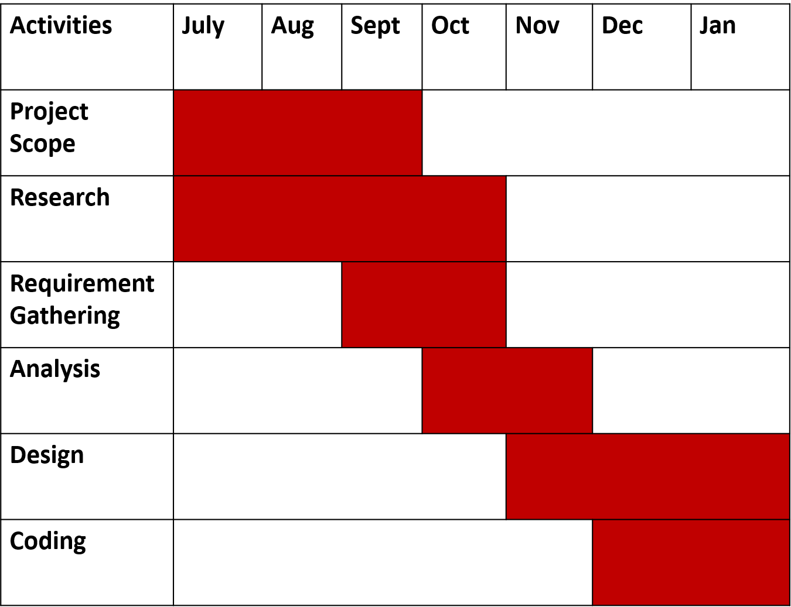

## **PROCESS MODEL**

**Waterfall Process Model:**

Software process is coherent set of activities for specifying, designing,

implementing and testing software system.

There are many different software process models but all involve.

* **Requirement Gathering and analysis** − All possible requirements of the system to be developed are captured in this phase and documented in a requirement specification document.
* **System Design** − The requirement specifications from first phase are studied in this phase and the system design is prepared. This system design helps in specifying hardware and system requirements and helps in defining the overall system architecture.
* **Implementation** − With inputs from the system design, the system is first developed in small programs called units, which are integrated in the next phase. Each unit is developed and tested for its functionality, which is referred to as Unit Testing.
* **Integration and Testing** − All the units developed in the implementation phase are integrated into a system after testing of each unit. Post integration the entire system is tested for any faults and failures.
* **Deployment of system** − Once the functional and non-functional testing is done; the product is deployed in the customer environment or released into the market.
* **Maintenance** − There are some issues which come up in the client environment. To fix those issues, patches are released. Also, to enhance the product some better versions are released. Maintenance is done to deliver these changes in the customer environment.

**Advantages of waterfall model**:

* advantages-of-waterfall-model
* It allows for departmentalization and managerial control.
* Simple and easy to understand and use.
* Easy to manage due to the rigidity of the model – each phase has specific deliverables and a review process.
* Phases are processed and completed one at a time.
* Works well for smaller projects where requirements are very well understood.
* A schedule can be set with deadlines for each stage of development and a product can proceed through the development process like a car in a car-wash, and theoretically, be delivered on time.

**Disadvantages of waterfall model:**

* It does not allow for much reflection or revision.
* Once an application is in the testing stage, it is very difficult to go back and change something that was not well-thought out in the concept stage.
* No working software is produced until late during the life cycle.
* High amounts of risk and uncertainty.
* Not a good model for complex and object-oriented projects.
* Poor model for long and ongoing projects.
* Not suitable for the projects where requirements are at a moderate to high risk of changing

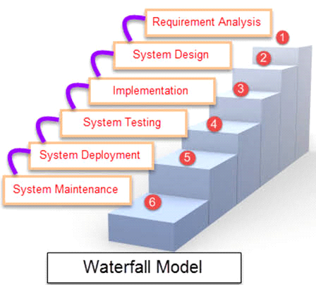

# **SYSTEM ANALYSIS AND PLANNING**

## **UML (UNIFIED MODELING LANGUAGE)**

### **Use Case Diagram**

#### **Use Case for Admin**

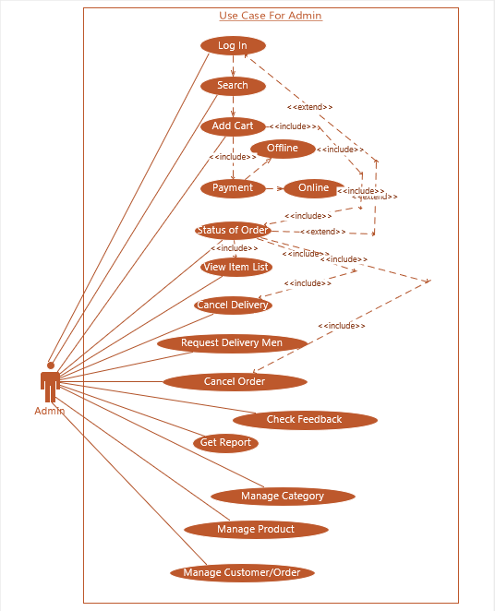

#### **Use Case for Customer**

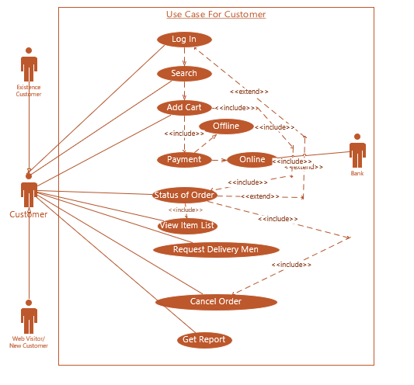

#### **Use Case for Deliverymen**

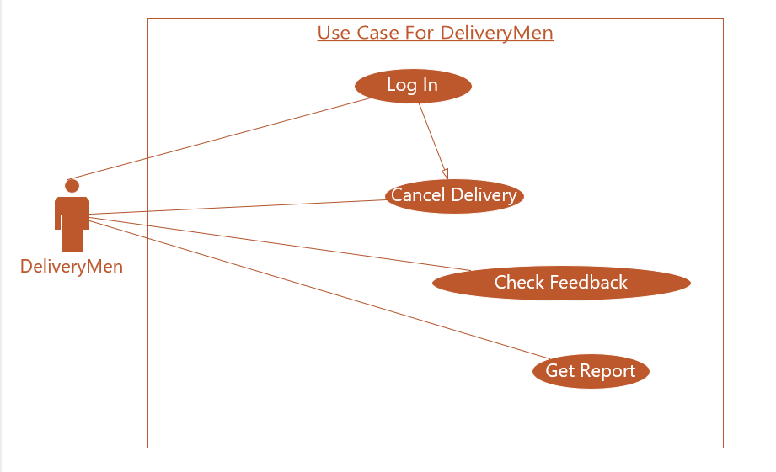

### **Sequence Diagram**

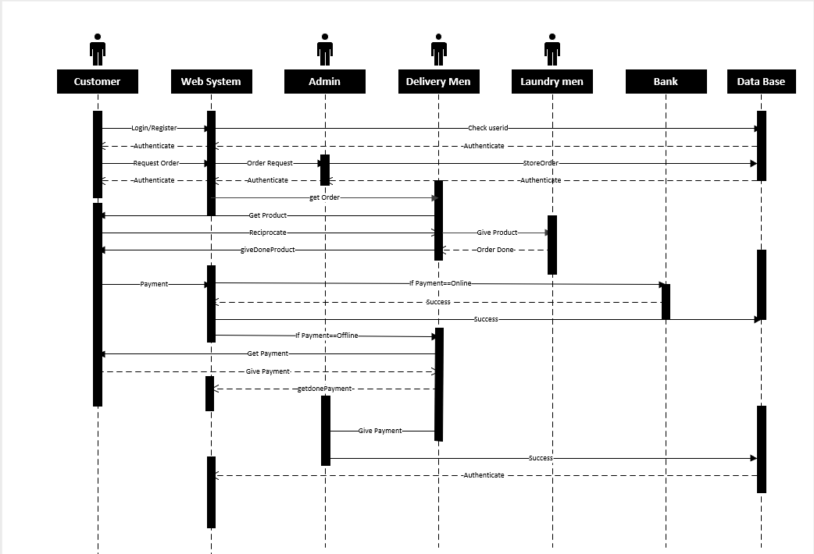

### **Activity Diagram**

#### **Admin**

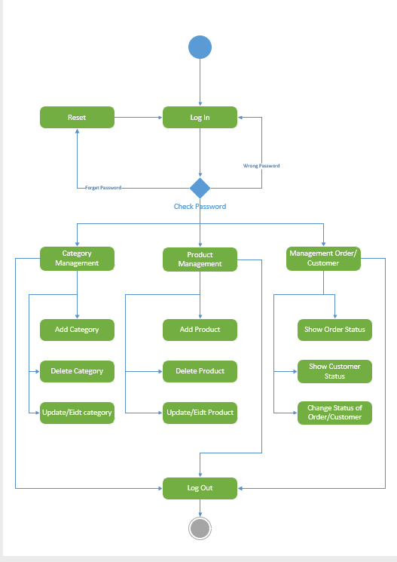

#### **Customer/User**

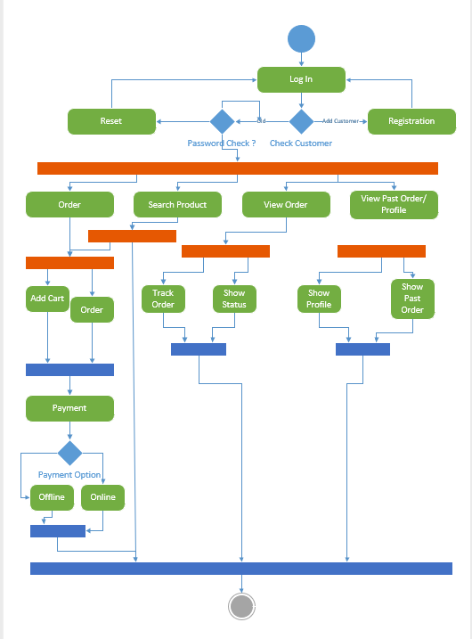

#### **Delivery Men**

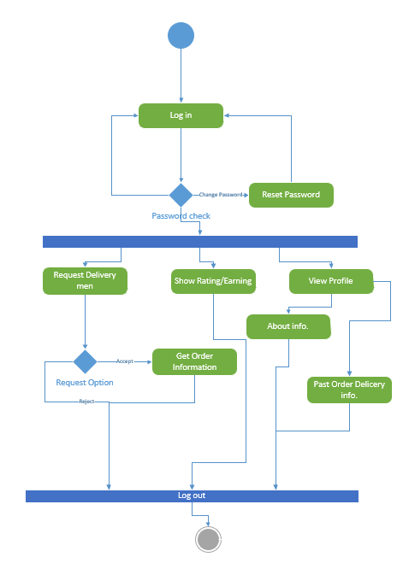

#### **Web Visitor**

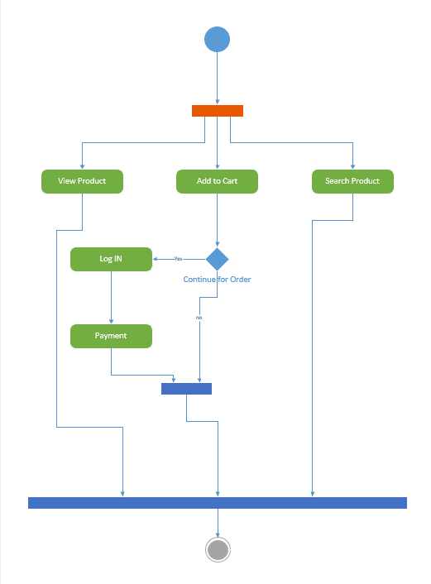

#### **Login/Registration**

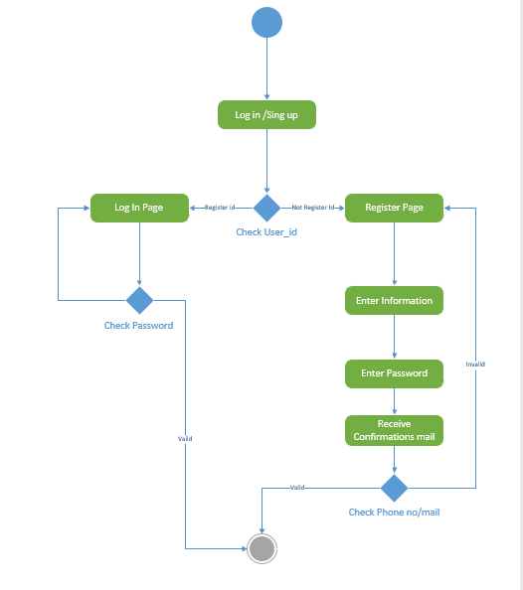

### **Class Diagram**

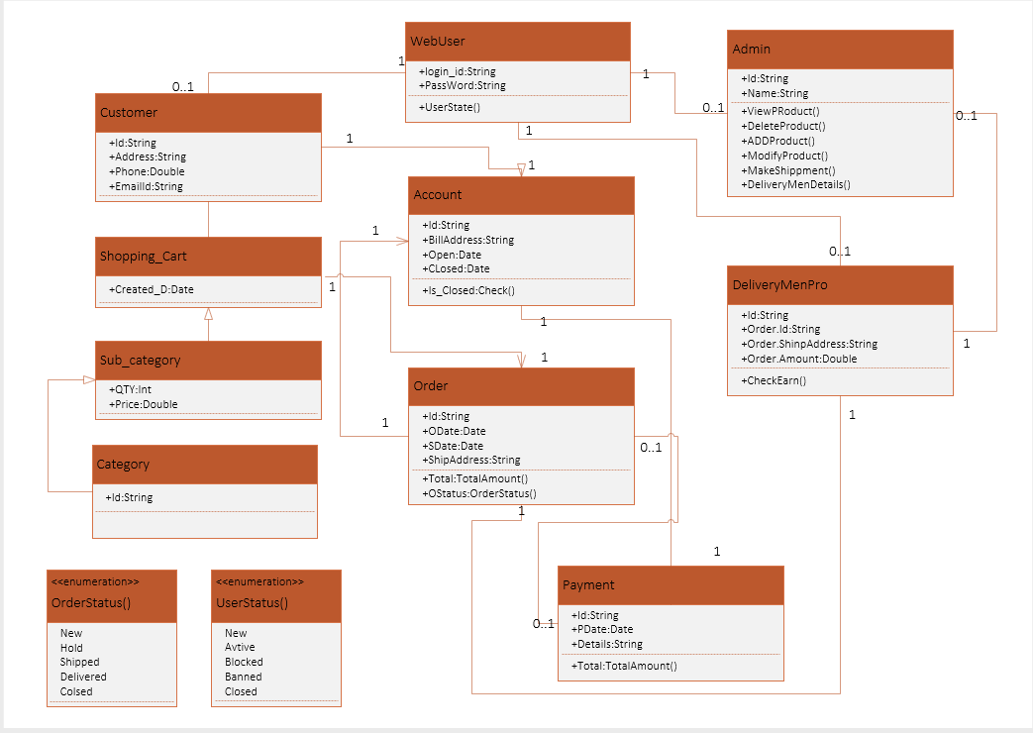

## **SYSTEM FLOW DIAGRAM**

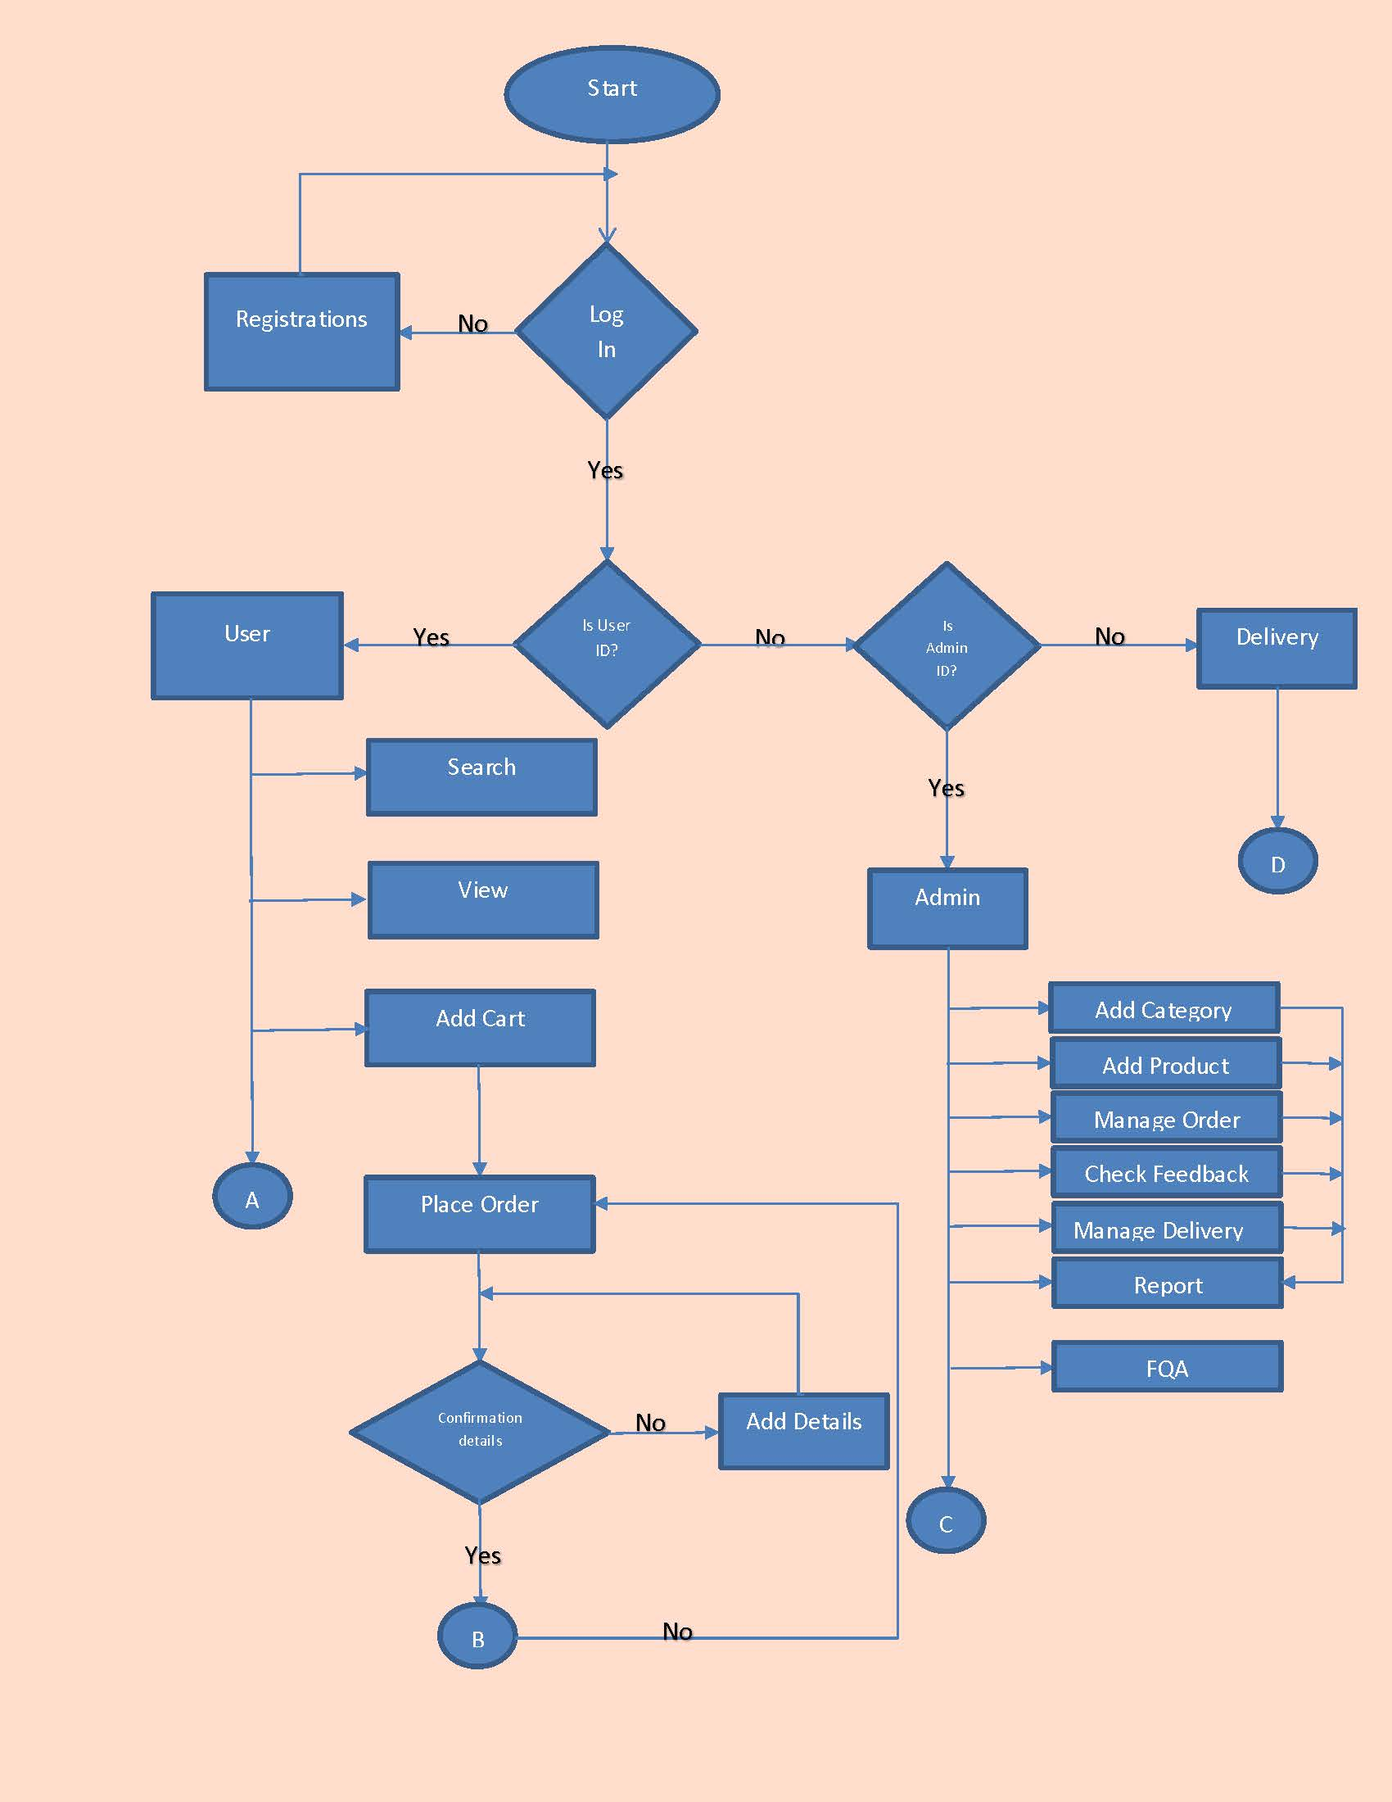

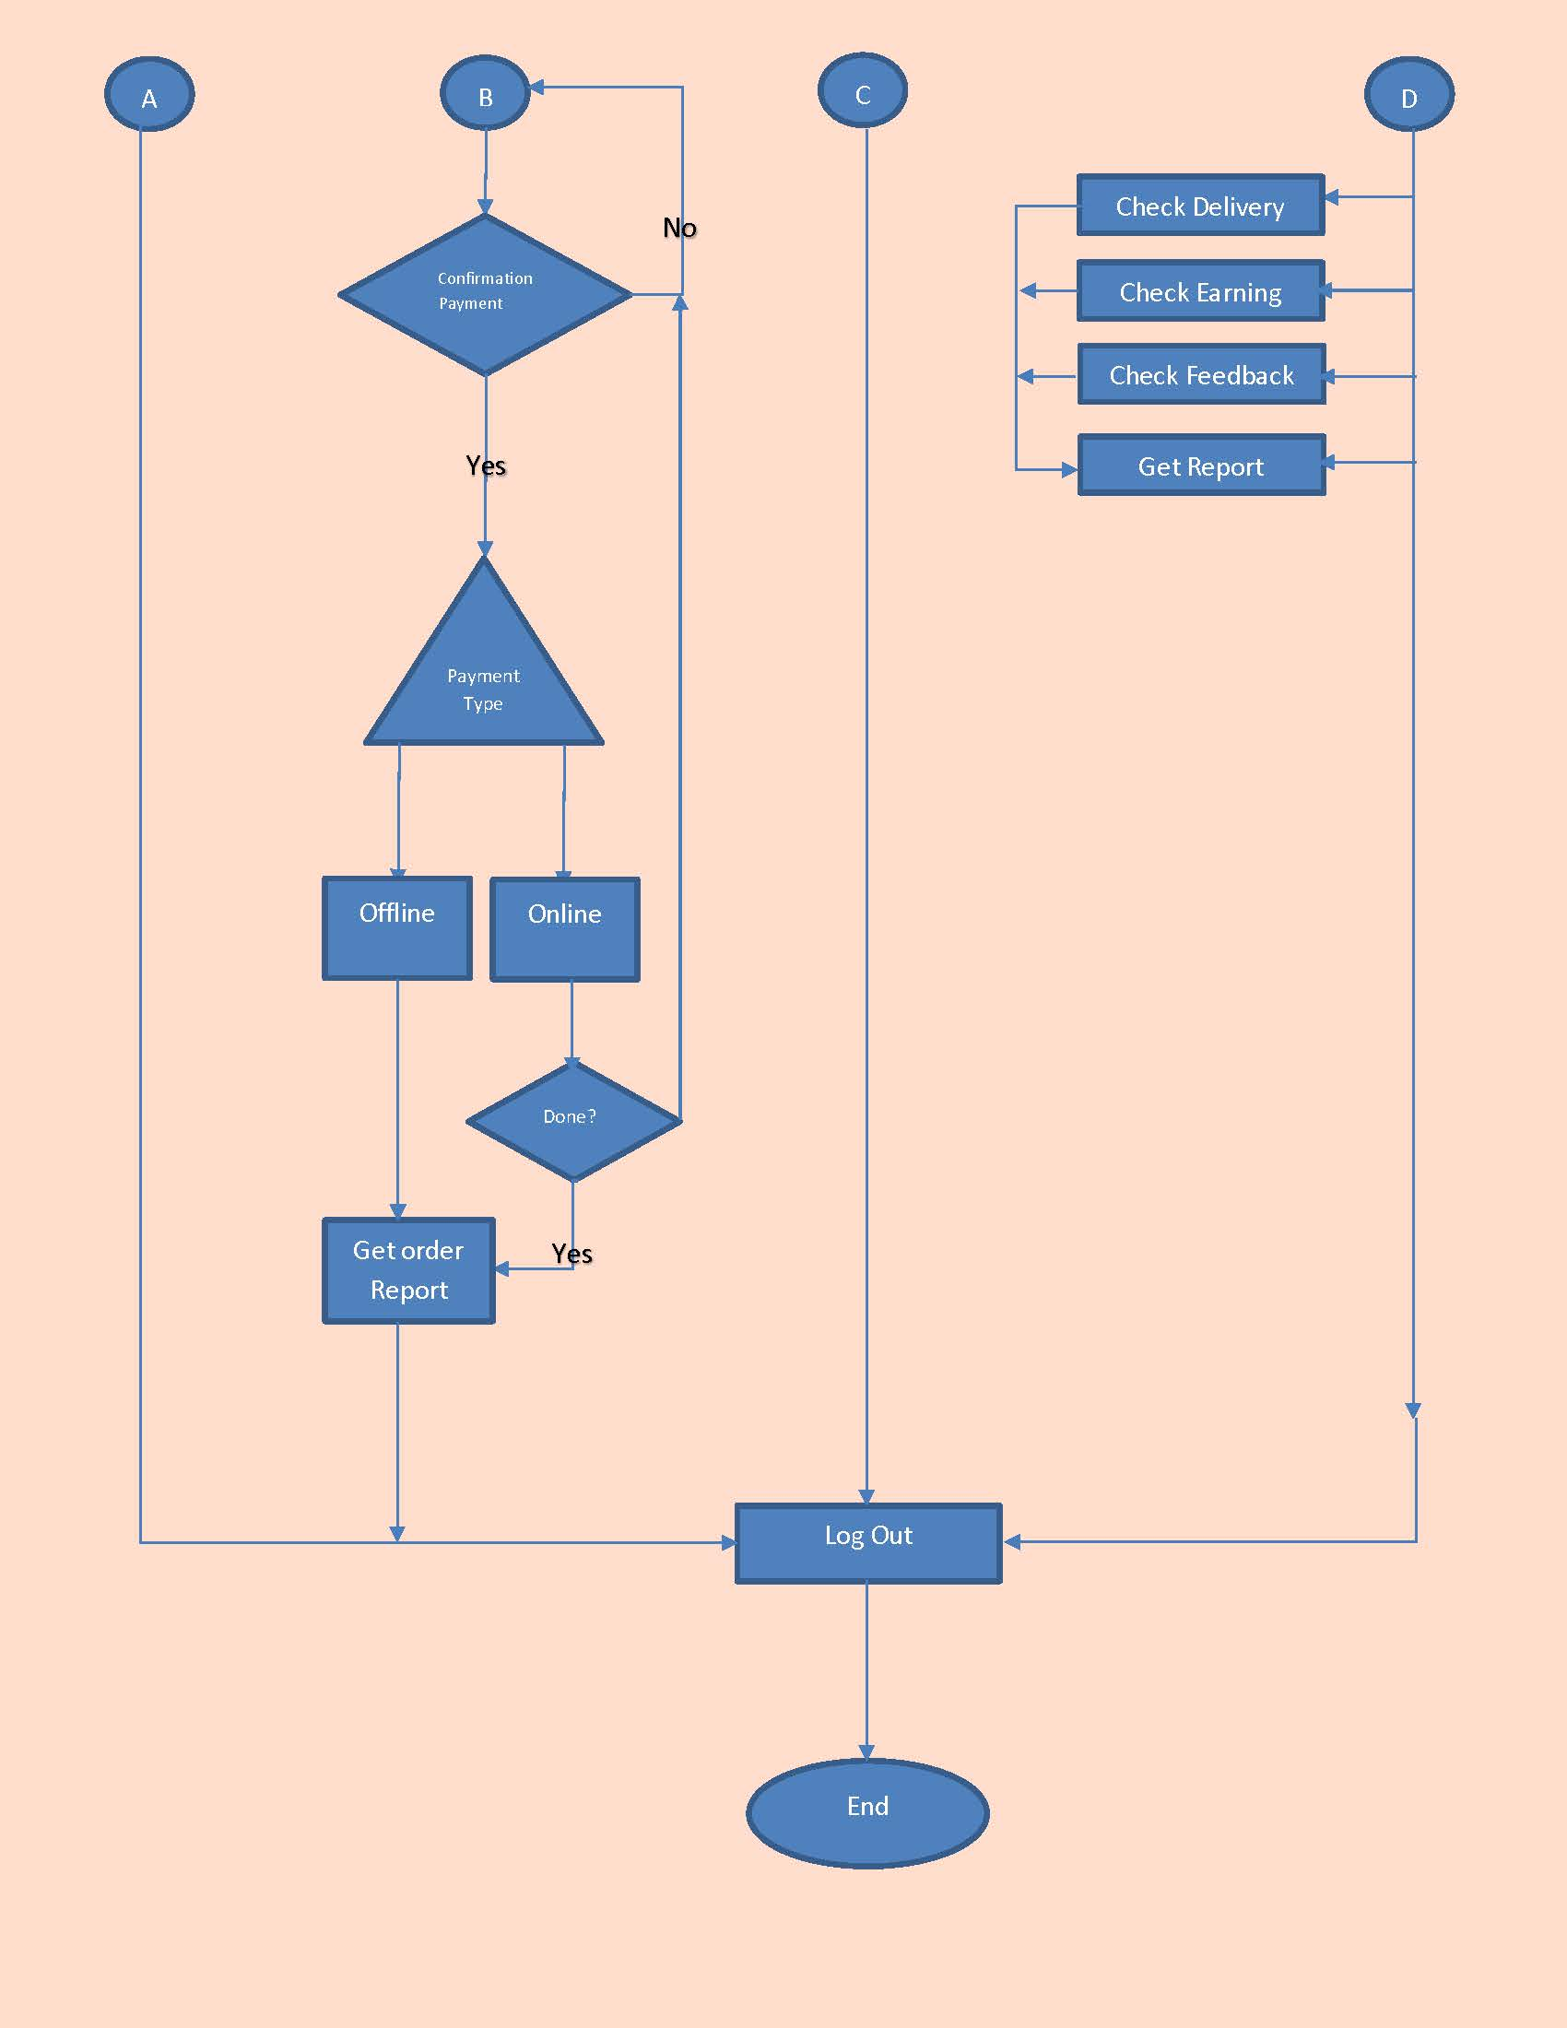

## **DATA DICTIONARY**

### **User**

|  |  |  |  |  |
| --- | --- | --- | --- | --- |
| Field Name | Data Type | Constraints | Field size | Description |
| User_id | Varchar | Primary key | 15 | Unique id of user |
| Username | Varchar | Not Null | 25 | User name |
| U_Email_Id | Varchar | Unique | 20 | Valid email  id of user |
| UserPhone | Int | Unique | 10 | Valid Phone no of user |
| UserPassword | Varchar | Not Null | 12 | Password for login |

### **Admin**

|  |  |  |  |  |
| --- | --- | --- | --- | --- |
| Field Name | Data Type | Constraints | Field size | Description |
| Admin_id | Varchar | Primary key | 15 | Unique id of Admin |
| Admin_Name | Varchar | Not Null | 25 | Admin name |
| Ad_Email_Id | Varchar | Unique | 20 | Valid email  id of Admin |
| Ad_Phone | Int | Unique | 10 | Valid Phone no of Admin |
| AdminPassword | Varchar | Not Null | 12 | Password for login |

### **Category**

|  |  |  |  |  |
| --- | --- | --- | --- | --- |
| Field Name | Data Type | Constraints | Field size | Description |
| Category_id | Int | Primary Key | 4 | Unique id of  category |
| Cate_name | Varchar | Not Null | 10 | Category Name |
| Image | Attachment | Not Null | 250kb | Category  Image |
| Sub_cat_id | Id | Foreign Key | 4 | Id of  subcategory |

### **Orders**

|  |  |  |  |  |
| --- | --- | --- | --- | --- |
| Field Name | Data Type | Constraints | Field size | Description |
| Order_id | Int | Primary Key | 4 | Unique id of order |
| Product_id | Int | Foreign Key | 5 | Order product id |
| Qty | Int | Not Null | 5 | Select Qty |
| Amount | Double | Not Null | 10 | Total amount of  Order |
| User_Name | Varchar | Foreign Key | 15 | Name of  customer |
| User_Email | Varchar | Foreign Key | 20 | Email of customer |
| User_Address | Varchar | Not Null | 100 | Address of customer |
| User_City | Varchar | Not Null | 10 | City of customer |
| User_State | Varchar | Not Null | 10 | State of customer |
| Phone | Int | Foreign Key | 10 | Phone of customer |

### **Order Updates**

|  |  |  |  |  |
| --- | --- | --- | --- | --- |
| Field Name | Data Type | Constraints | Field size | Description |
| Update_id | Int | Primary Key | 4 | Unique update  id of order |
| Order_id | Int | Foreign Key | 4 | Old order id |
| Update_detail | Varchar | Not Null | 50 | Order update  description |
| Update_Qty | Int | - | 5 | Change in qty |
| Updated_amount | Double | Not Null | 10 | Change in Amount |
| Date | Date | Not Null | - | Date Details |

### **Product**

|  |  |  |  |  |
| --- | --- | --- | --- | --- |
| Field Name | Data Type | Constraints | Field size | Description |
| Product_id | Varchar | Primary Key | 4 | Unique product id |
| Price | Int | Not Null | 20 | Price of the product |
| Description | Varchar | Not Null | 50 | Description of product |
| Image | Varchar | Not Null | 10 | Image of  product |
| Category_id | Int | Foreign Key | 4 | Category id of  the product |
| Sub_cat_id | Int | Foreign Key | 4 | Sub_cat_id of product |

### **Sub-Category**

|  |  |  |  |  |
| --- | --- | --- | --- | --- |
| Field Name | Data Type | Constraints | Field size | Description |
| Sub_cat_id | Int | Primary Key | 4 | Unique  sub_cat_id |
| Sub_cat_name | Varchar | Not Null | 15 | Subcategory  name |
| Image | Varchar | Not Null | 10 | Image of  sub_category |
| Category_id | Int | Foreign Key | 4 | Category id |
| Sub_cat_id | Int | Primary Key | 4 | Unique  sub_cat_id |
| Sub_cat_name | Varchar | Not Null | 15 | Sub_category  name |

### **Delivery men Info.**

|  |  |  |  |  |
| --- | --- | --- | --- | --- |
| Field Name | Data Type | Constraints | Field size | Description |
| Del_id | Varchar | Primary key | 15 | Unique id of Deliverymen |
| Del_Name | Varchar | Not Null | 25 | Deliverymen name |
| Ad_Del_Id | Varchar | Unique | 20 | Valid email  id of Deliverymen |
| Del_Phone | Int | Unique | 10 | Valid Phone no of Deliverymen |
| DelPassword | Varchar | Not Null | 12 | Password for login |

### **Payment**

|  |  |  |  |  |
| --- | --- | --- | --- | --- |
| Field Name | Data Type | Constraints | Field size | Description |
| Pay_id | Varchar | Primary key | 10 | Payment id |
| User_id | Varchar | Foreign key | 10 | user id |
| name | Varchar | Foreign key | 6 | name |
| status | date |  | 8 | Status paid/unpaid |

## **USER INTERFACE**

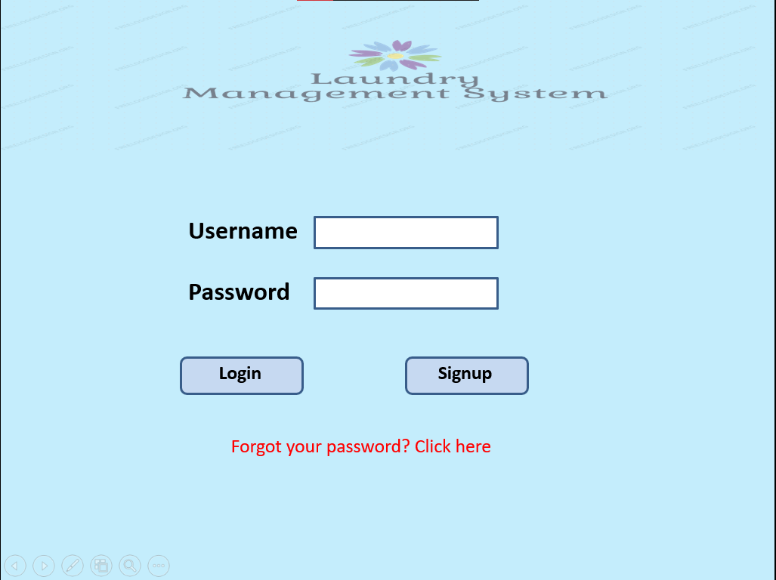

* **Login Page**
* **Sign Up**

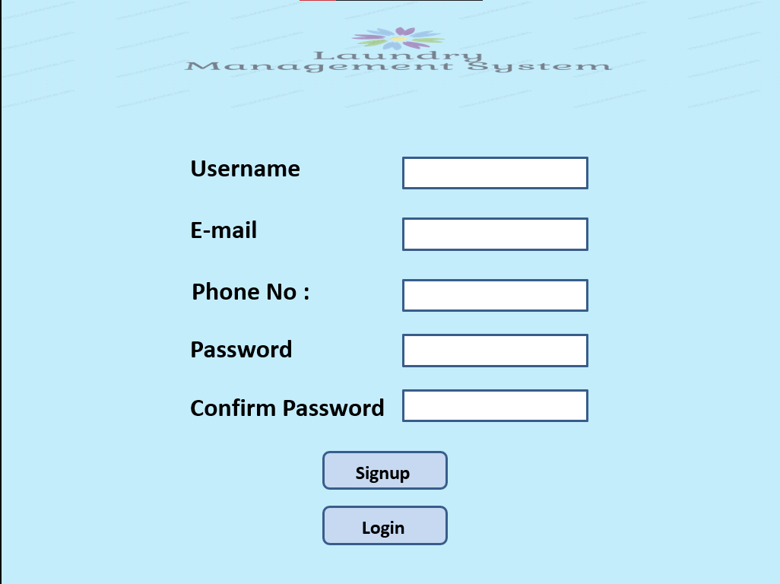

* 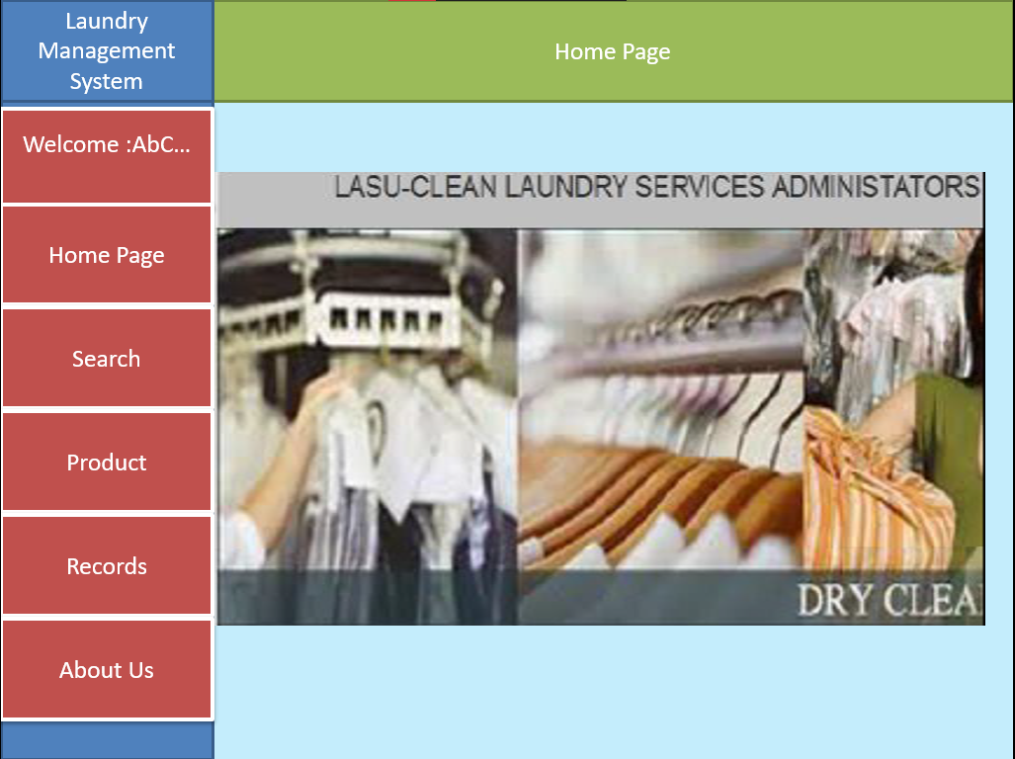**Homepage**
* **My Profile**

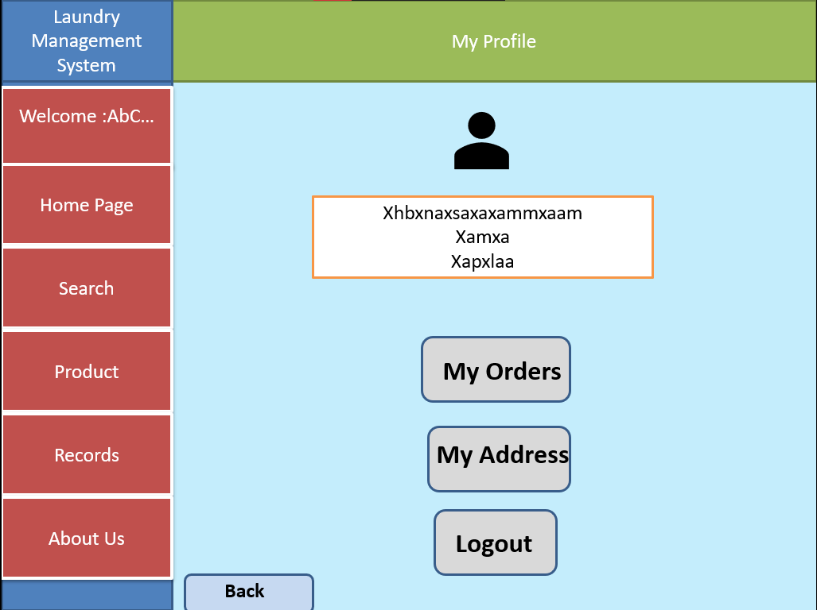

* **Search & Products Page**

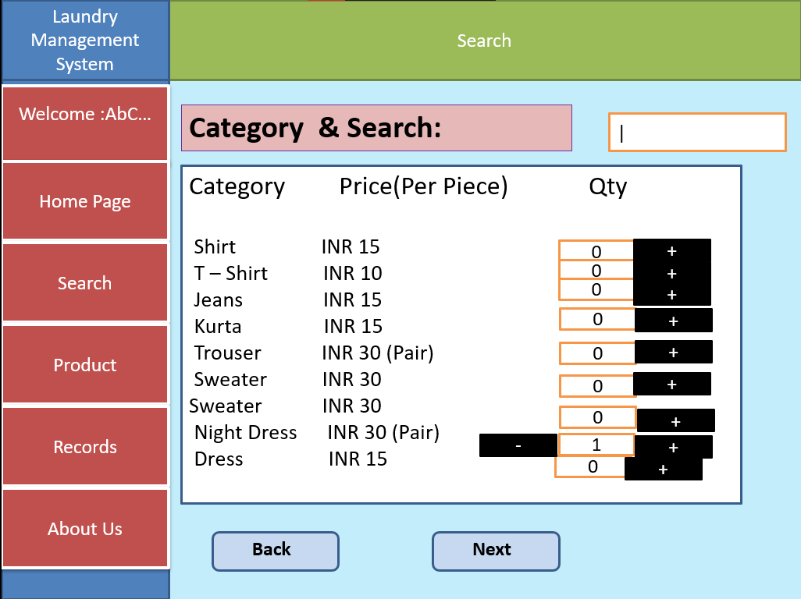

* **Product Registration Page**

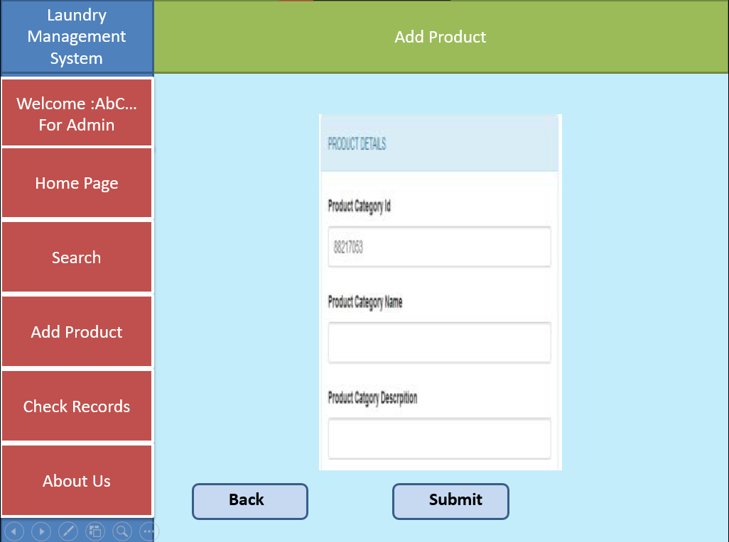

* 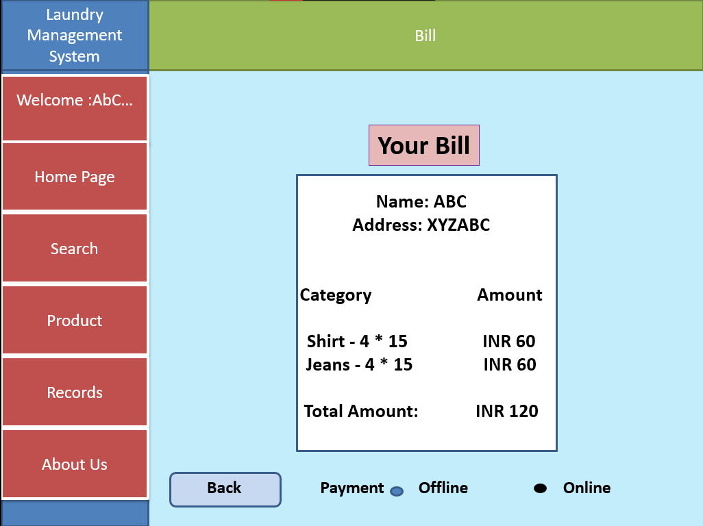**Receipt Page**
* 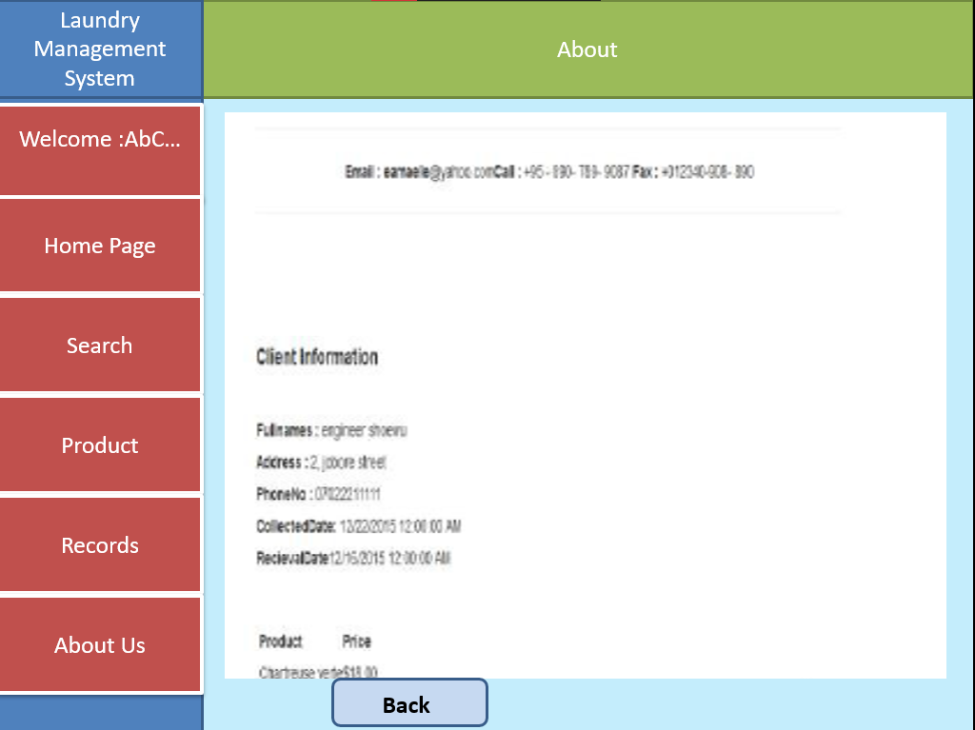**About**
* **Search Customer**

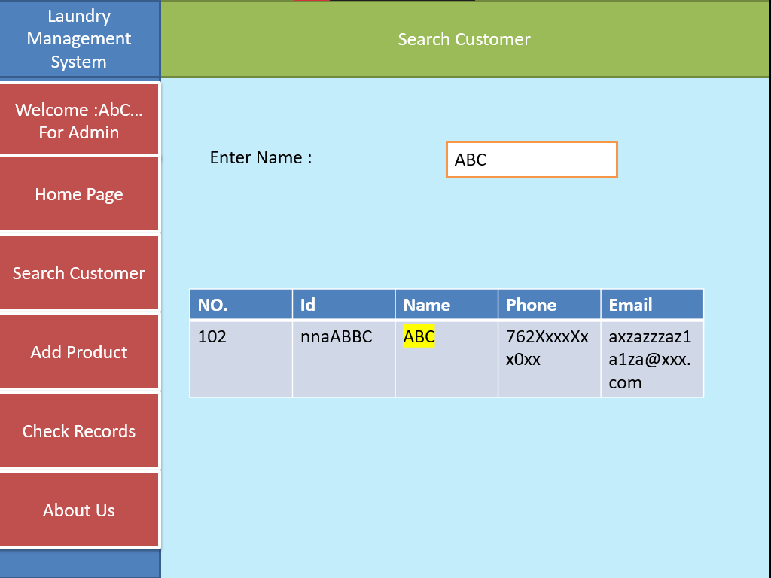

## **SYSTEM NAVIGATION**

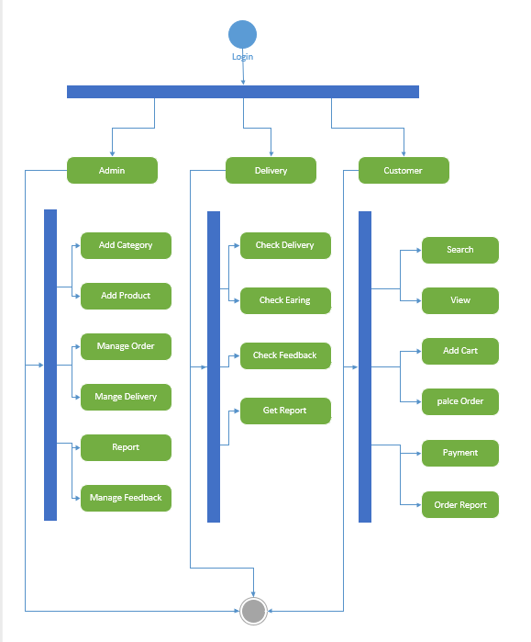

# **Conclusion**

The experience of doing this project with emerging technologies was really exciting for me. I learnt many things, which are far from being technical. Various issues like problem application, interacting with different people etc. were few of these valuable things.

This is the final year project of B.Sc. (CA & IT), and it was the great adventure and experience at collage.

We would like to thank the project guides for support and helped us to complete this project successfully.

All in all, this entire project has prepared me fully for what we are going to face in the IT field in future. And we are very thankful for that to department and university to putting this kind of project as subject which is helpful in final semester project.

To conclude, “Laundry Management System” gave us a solid foundation on which we would be able to build a successful career ahead. This project has been a wonderful working experience and will become an ever...!!!

# **References**

[www.javatpoint.com](http://www.javatpoint.com)

[www.google.com](http://www.google.com)

# **Bibliography**

*`***PHP Book**

Shoewu, O., Makanjuola, N.T., Phillips, D.A. and Emmanuel, A. (2016) “*Design and Implementation of a Laundry Management System*”. Pacific Journal of Science and Technology. 17(2):197-204.

Zalilawati binti Ghazhali (2008) “Design and Implementation of a Laundry Management System” Universiti Teknical Malaysia Maleka, Malaysia